MODERN DATABASE SYSTEMS LAB 6

RETAIL SALES ANALYTICS PART2

NAME: PAVITHIRAN.V ROLL NO: 235229122

Question 1:

SELECT s.dept, s.DATE1, s.WEEKLY_SALES, s.ISHOLIDAY, f.STORE_ID

FROM sales_data s, features_data f

WHERE s.STORE_ID = f.STORE_ID

FETCH FIRST 3 ROWS ONLY;

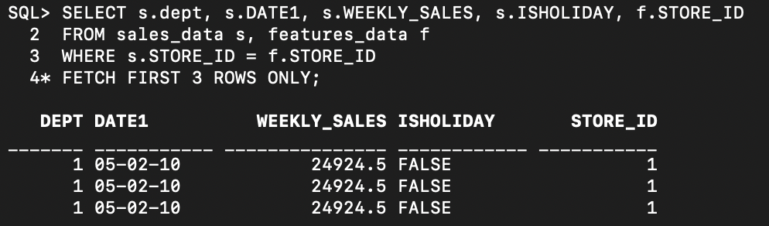

SELECT s.STORE_ID, s.TEMPERATURE, s.CPI, sa.WEEKLY_SALES

FROM features_data s, sales_data sa

WHERE s.STORE_ID = sa.STORE_ID

FETCH FIRST 3 ROWS ONLY;

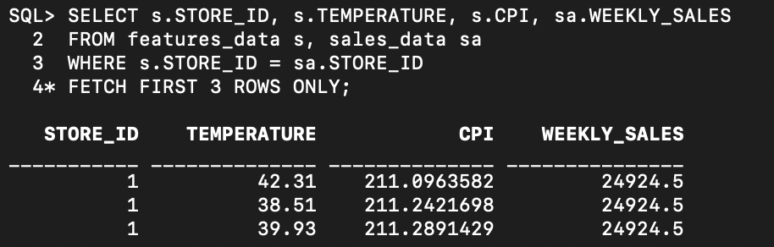

SELECT s.DEPT, f.TEMPERATURE, f.FUEL_PRICE, s.STORE_ID

FROM sales_data s

JOIN features_data f ON s.STORE_ID = f.STORE_ID

FETCH FIRST 3 ROWS ONLY;

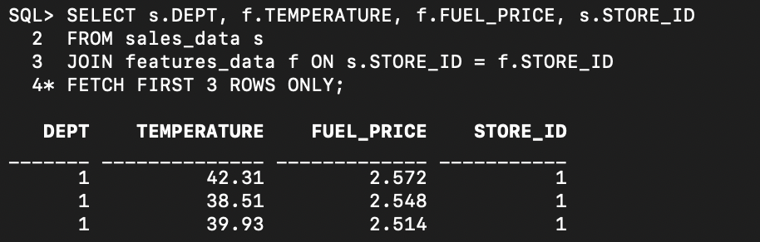

Question 2:

SELECT s.DEPT, f.TEMPERATURE, f.FUEL_PRICE, s.STORE_ID

FROM sales_data s

LEFT JOIN features_data f ON s.STORE_ID = f.STORE_ID

FETCH FIRST 3 ROWS ONLY;

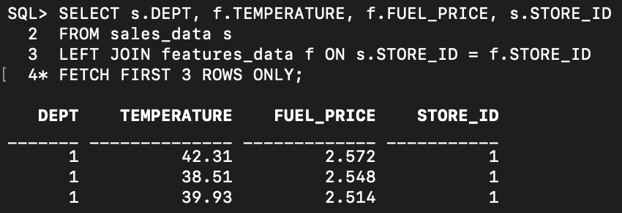

SELECT s.DEPT, s.DATE1, s.WEEKLY_SALES, s.ISHOLIDAY, f.STORE_ID

FROM sales_data s

LEFT JOIN features_data f ON s.STORE_ID = f.STORE_ID

FETCH FIRST 3 ROWS ONLY;

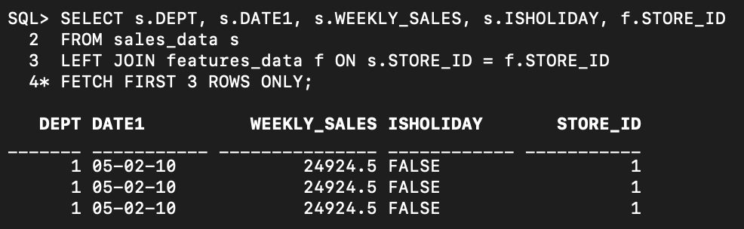

SELECT s.STORE_ID, s.TEMPERATURE, s.CPI, sa.WEEKLY_SALES

FROM features_data s

LEFT JOIN sales_data sa ON s.STORE_ID = sa.STORE_ID

FETCH FIRST 3 ROWS ONLY;

